Name:____________________________________________ Date:______________________

**Multiplying Non-Unit Fractions and Whole Number Pictorially and Symbolically**

**Directions: Use the visuals to support your answer. Be sure to include the division problem you used to solve each problem below. The first one has been completed for you as an example.**

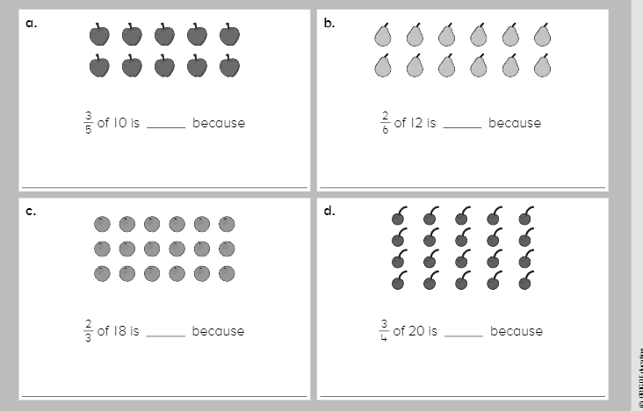

6

(10 ÷ 5) x 3 = 6

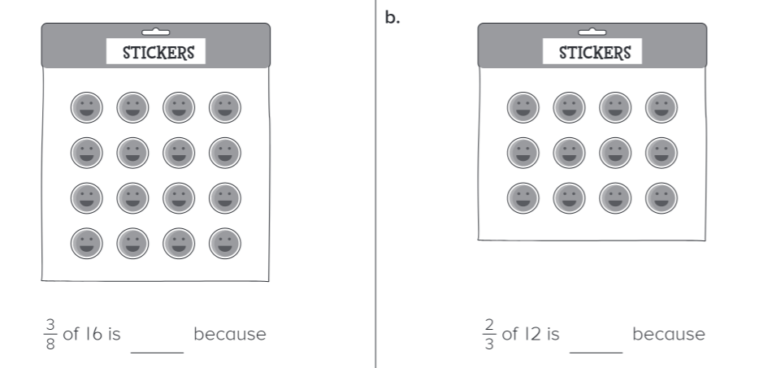

**Directions: Solve each of the following equations. Show your thinking. The first one has been completed for you as an example.**

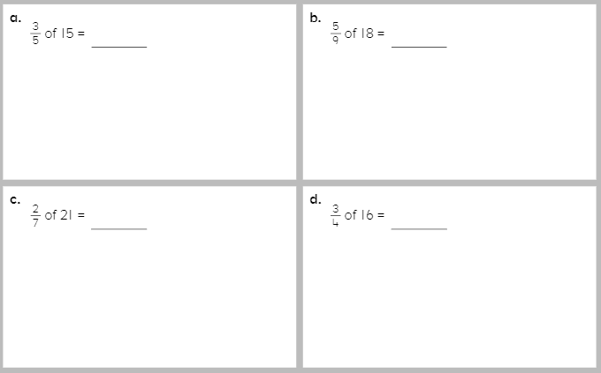

$(\frac{1}{5} x 15) x 3 =\frac{45}{5}$ = 9

